**DAILY ONLINE ACTIVITIES SUMMARY**

|  |  |  |  |  |  |  |  |  |
| --- | --- | --- | --- | --- | --- | --- | --- | --- |
| **Date:** | **10-06-2020** | | | | | **Name:** | **Shiza Amreen.J** | |
| **Sem & Sec** | **4th sem B sec** | | | | | **USN:** | **4AL18CS078** | |
| **Online Test Summary** | | | | | | | | |
| **Subject** | | **Object Oriented Concepts** | | | | | | |
| **Max. Marks** | | **30** | | **Score** | | | **18** | |
| **Certification Course Summary** | | | | | | | | |
| **Course** | **Introduction to Cyber Security** | | | | | | | |
| **Certificate Provider** | | | **GreatLearning** | | **Duration** | | | **5.5 Hours** |
| **Coding Challenges** | | | | | | | | |
| **Problem Statement:** **Java Program to find the longest repeating sequence in a string string:acbdfghybdf** | | | | | | | | |
| **Status: Completed** | | | | | | | | |
| **Uploaded the report in Github** | | | | | **yes** | | | |
| **If yes Repository name** | | | | | **Lockdown_Coding** | | | |
| **Uploaded the report in slack** | | | | | **yes** | | | |

Online Test Details:

Today we had OOC IA-3, I have attended the test and have got 18 out of 30.

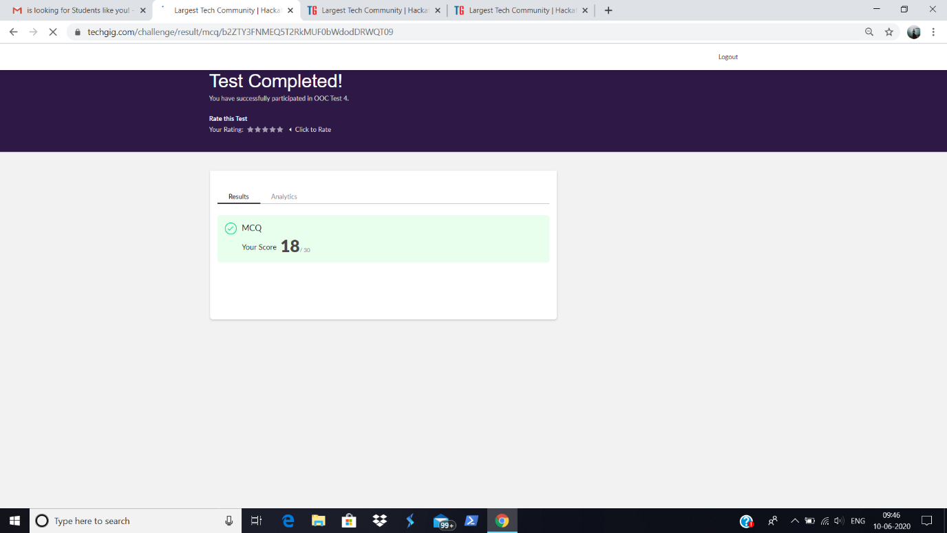

Certification Course Details:

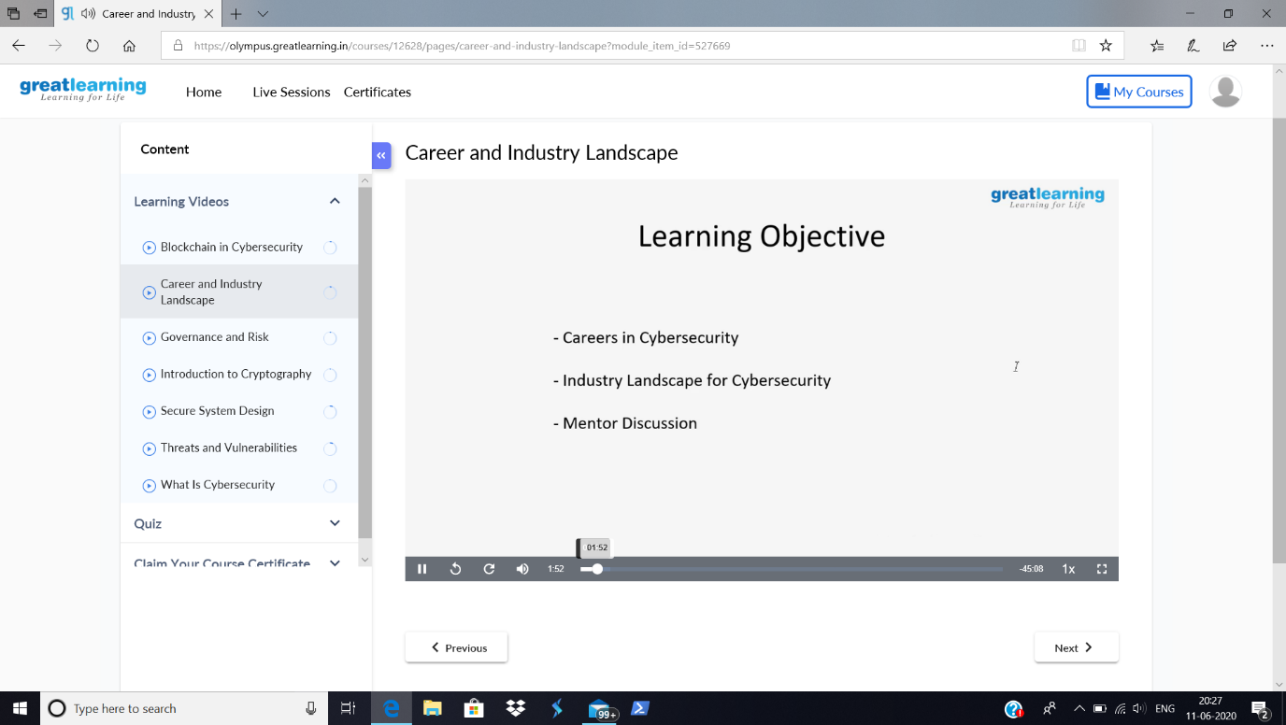

Today in the course, introduction to Cyber Security, I have learnt about Learning Objectives.

Coding Challenges Details:

**Problem Statement:** **Java Program to find the longest repeating sequence in a string  
string:acbdfghybdf**

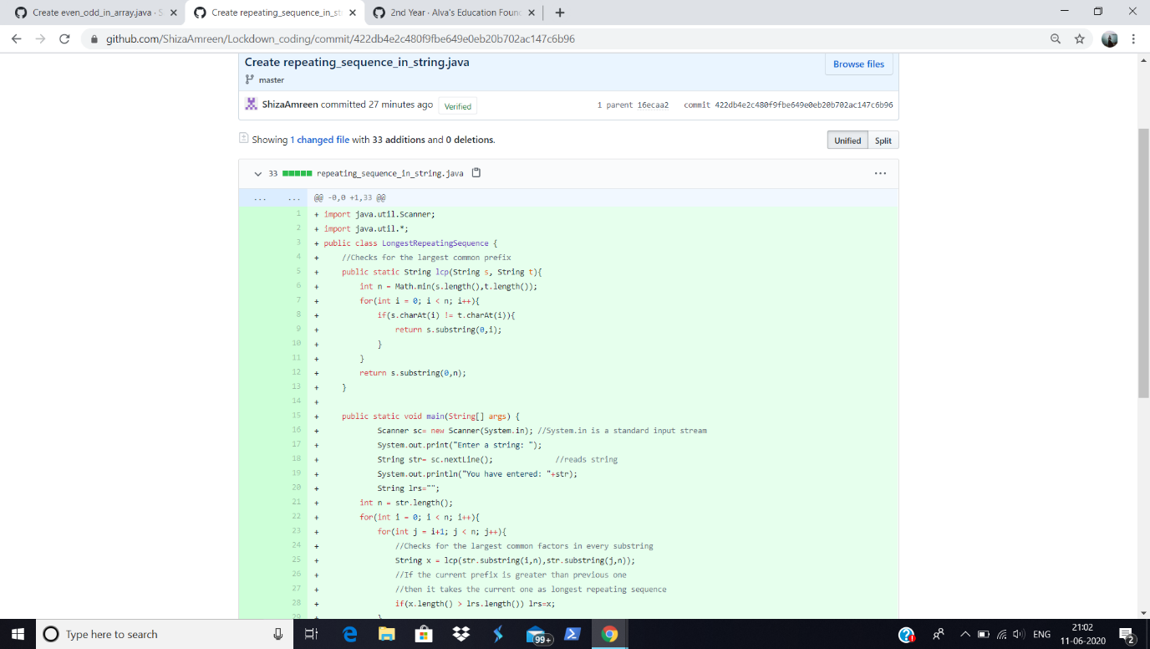

I have written the code for given problem statement and have uploaded it in my github repository.

<https://github.com/ShizaAmreen/Lockdown_coding/commit/422db4e2c480f9fbe649e0eb20b702ac147c6b96>